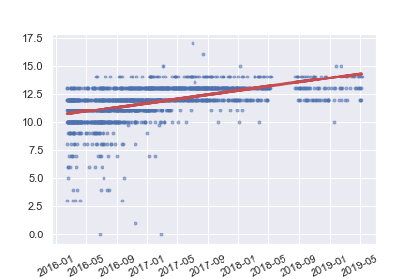Pup Inflation

Rating Score

Time

This blog post aims to answer the question: is there an inflation in the ratings of dog pictures from twitter? Firstly, the first diagram is plotted with the score given against time, the blue dots represent count of the score. From this diagram, we can see that there is generally an increase in score given when time increases based on the red linear regression line. This line is a prediction of the relationship between the score and time. So as time increase, so does our score.

p-value = 3.793 \* 10^-121

Secondly, this plot aims to see if our claim that the predicted line is increasing? We do this by plotting a histogram with the actual score minus our predicted score. The histogram shows us that the distribution is approximately normal and therefore we can reject H0 where the slope is 0. Thus, concluding that the regression line is not a flat line which is what we can see in the scatter plot.